**\*Points for areas that can be improved**

**1. The navigation bar's gradient background makes the text slightly hard to read, especially in areas where the contrast is low.**

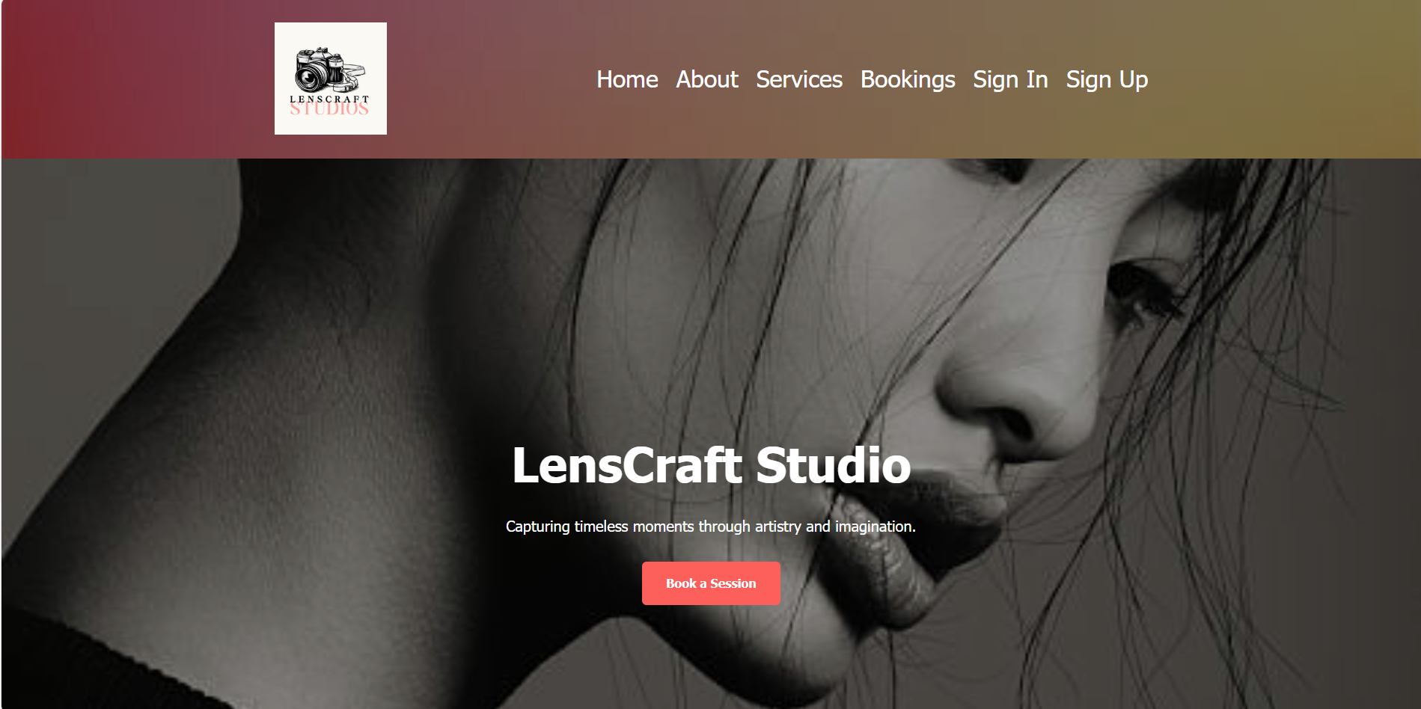

**\*How to improve**

**1. Use a solid background color or a more subtle gradient with better contrast. Alternatively, add a slight text shadow or increase the font weight to enhance readability.**

**\*Points for areas that can be improved**

**2. The text contains several grammatical errors, awkward phrasing, and inconsistencies that make it difficult to understand and unprofessional.**

**\*How to improve**

**2. Example Rewrite for the First Paragraph:  
"Welcome to London’s Studio, located in the heart of Cuba Street, Wellington. We specialize in custom event photography, capturing unforgettable moments from sunrise portraits to commercial projects. Our passion is delivering timeless, high-quality imagery that tells your unique story."**

**\*Points for areas that can be improved**

**3. The text under each service category (e.g., "Weddings," "Portraits") is fragmented and unclear, making it difficult for users to understand the offerings**.

**\*How to improve**

**Rewrite the descriptions to be concise, coherent, and engaging. For example:**

* **Current: "Lam photography is one of tension and exercise energy"**
* **Improved: "Lam Photography captures the essence of your special moments with creativity and precision, ensuring timeless memories."**

**This change will enhance readability and better communicate the value of each service.**

**\*Points for areas that can be improved**

**4. Expand navigation options and test responsiveness on various devices**



**\*How to improve**

**Test Responsiveness on Various Devices**

* **Mobile Optimization: Ensure the navigation collapses into a well-styled hamburger menu for smaller screens.**
* **Touch-Friendly Buttons: On mobile, buttons should be large enough to tap easily (44x44px minimum).**
* **Text & Images Scaling: Ensure text is readable and images adjust correctly across different screen sizes**

2*//You can change the background image //



**Overall, "Your website has a clean, minimalist foundation—great for readability and fast loading!**